RESUME
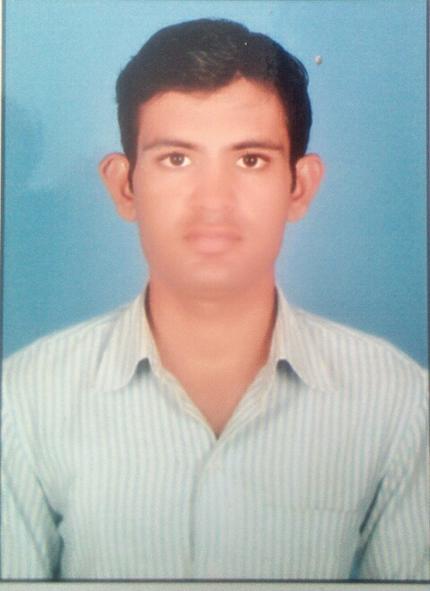

Suraj pol ahore,
Dist. Jalore, [ Rajasthan] Pin cod=307029
Mobile no. + 8094859639
Lalitpg38@@gmail.com
LALITPURI GOSWAMI
CAREER OBJECTIVE :-
An honest and sincere approach towards my success and that of my benefactors. Brought about my ability to work under pressure and task-oriented environment, ability to work with team spirit, clearity of vision and sincerity in action. Active. Listening qualities and willingness to work even in adverse situation.
EDUCATIONAL QUALIFICATIONS:-
EXAM | INSTITUTION | BOARD/UNIVERSITY | PASSING YEAR
B.A. II | private | JNVU Jodhpur | runing
XII (ARTS) | Govt. sr. sec. school, ahore | Raj. Board ajmer | 2013
X | Govt. sr. sec. school, ahore | Raj. Board ajmer | 2011
Computer qualification
Professional qualification

- computer all ms office work
- All internet work
- Rs –cit course runing

EXPERINCE:-

- RSBY computer opretre (SAFAY T.P.A. JAIPUR )
- Sbbj bank account work 1year 2 month

SKILLS

Basically full knowledge for teaching for hindi subject

PERSONAL DETAILS:-

NAME : Lalpuri goswami
FATHER’ S NAME : laxman puri goswami
D.O.B. : 09-08-1993
ADDRESS : SURAJ POL ,AHORE
DIST. : JALORE
NATIONALITY : INDIAN
GENDER : MALE

I AM ASSURING YOU OF MY SINCERITY AND HARD WORK.

YOUR SINCERELY 